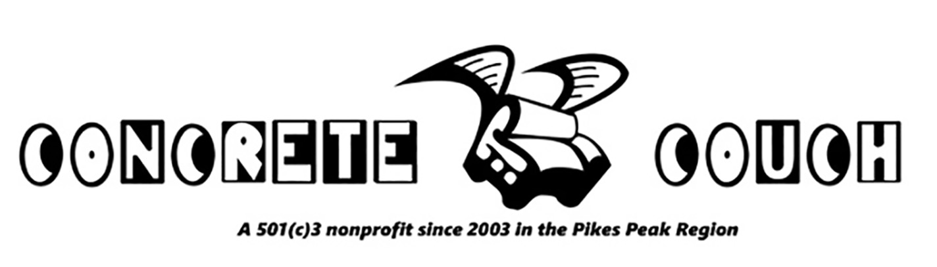

PROJECT PLANNING SHEET for HOST ORGANIZATIONS

This is a general outline to help you define what you want to achieve from a project with CC, and learn more about how we will work together. We offer a free initial planning meeting. To make this session optimally productive, please complete this form and send to us before we meet.

Project: What will we do? Build something? Create and perform a puppet show? Grow food for the lunch
program? Start an engineering-construction program? If not specific ideas, then share some thoughts on
your group’s interests, challenges, mission, vision or general character of the community.

Goals: What is the goal of our collaboration? Some examples: to build community; to brighten up a school; to help visitors find the library; to engage our most at-risk students; to integrate new/foreign students with larger student body; to make something useful your organization needs; to engage the community with your organization and its mission. Often groups have several goals.

Group: Who will be the participant group, who you wish to engage? (IE: The third grade; “at-risk teens”; senior citizens.) You may want several groups and the larger community involved.

Spaces: Will we work on site, or at a remote location? Where will we store materials and tools? Think about work areas (and the times they are available) and list possibilities.

Timeline: Do you have a general timeline? Is there a date of completion you are shooting for? Also consider which are possible work days and times (“early release Wednesdays, from 2 to 3:30 PM”).

Budget: We will help you develop a workable budget, and make a list of your “community assets”: people, institutions and businesses from your community who can contribute materials, tools, food, technical expertise, meeting/working spaces, and funds. These connections are the backbone of a truly great community effort…and will continue to aid you in future endeavors.

Leaders: Who will be spearheading the program? Often several people from your organization will be involved, each with different roles. Sometimes it makes sense for people from other organizations to be involved. Ideally all these people will attend our first planning session!

Contract: Often our initial meeting will be at your organization, or at the project site (if different from the organization’s location). After this meeting, plan on communicating (usually via e-mail) over the next week or two, as we all work to develop a finalized plan and contract. The contract is a valuable tool: it delineates who will do what, and when. (We are all more relaxed and efficient when we know our specific roles and what is expected of us.)

Financials: As a general estimate, we charge $500 for each facilitated session, inclusive of planning time and materials.

Payment: We ask you to process our payment so that a check can be delivered to us on the last day of a project. This simplifies bookkeeping, and helps keep our programs affordable.

For More info:
Steve Wood (director) 719-373-7694
steve@concretecouch.org
www.concretecouch.org

